

英飞凌ISG0614N06NM5H功率晶体管
最终数据手册

MOSFET
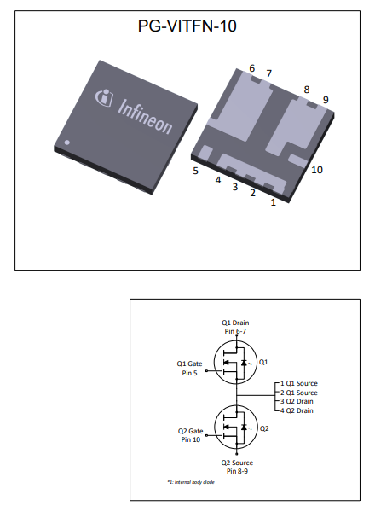

英飞凌工业用高耐热 60 V OptiMOSTM 5 功率晶体管
特性
- 对称半桥
- 针对低压驱动和电池供电应用进行了优化
- 针对高性能 SMPS 进行了优化
- N沟道
- 极低的导通电阻 RDS(on)
- 卓越的耐热性
- 100% 雪崩测试
- 无铅镀层；符合RoHS标准
- 符合 IEC61249-2-21 标准的无卤素

产品验证
完全符合 JEDEC 工业应用标准




表 1 主要性能参数
Parameter | Value | Unit
VDS | 60 | V
RDS(on),max | 1.6 | mΩ
ID | 233 | A
Qoss | 74 | nC
QG (0V..10V) | 68 | nC

本数据手册的原文使用英文撰写。为方便起见，英飞凌提供了译文；由于翻译过程中可能使用了自动化工具，英飞凌不保证译文的准确性。 为确认准确性，请务必访问 infineon.com 参考最新的英文版本（控制文档）。

Datasheet Please read the sections "Important notice" and "Warnings" at the end of this document Revision 2.0
www.infineon.com 2023-12-05

Type / Ordering Code | Package | Marking | Related Links
ISG0614N06NM5H | PG-VITFN-10 | 614N06N5H | -

目录
描述 1
最大额定值 3
热特性 3
电气特性 4
电气特性图 6
封装外形 10
修订记录 11
商标 11
免责声明 11

- 最大额定值
除非另有规定， TA = 25 °C

表 2 最大额定值
Parameter | Symbol | Values |  |  | Unit | Note / Test Condition
Parameter | Symbol | Min. | Typ. | Max. | Unit | Note / Test Condition
Continuous drain current¹⁾ | ID | -  - | -  - | 233  165 | A | VGS=10 V, TC=25 °C  VGS=10 V, TC=100 °C
Continuous drain current¹⁾ | ID | - | - | 31 |  | VGS=10V, TA=25°C, RTHJA=50°C/W²⁾
Pulsed drain current³⁾ | ID,pulse | - | - | 932 | A | TA=25 °C
Avalanche energy, single pulse⁴⁾ | EAS | - | - | 313 | mJ | ID=50 A, RGS=25 Ω
Gate source voltage | VGS | -20 | - | 20 | V | -
Power dissipation | Ptot | -  - | -  - | 167  3.0 | W | TC=25 °C  TA=25 °C, RTHJA=50 °C/W²⁾
Operating and storage temperature | Tj, Tstg | -55 | - | 175 | °C | -

- 热特性

表3 热特性
Parameter | Symbol | Values |  |  | Unit | Note / Test Condition
Parameter | Symbol | Min. | Typ. | Max. | Unit | Note / Test Condition
Thermal resistance, junction - case | RthJC | - | 0.6 | 0.9 | °C/W | -
Thermal resistance, junction - ambient, 6 cm² cooling area²⁾ | RthJA | - | - | 50 | °C/W | -

¹⁾额定值指产品仅具有数据表指定的绝对最大值，保持外壳温度符合规定要求。其他外壳温度请参见图 2。需要根据实际环境条件降低额定值。
²⁾ 器件安装在 40 mm x 40 mm x 1.5 mm环氧树脂印刷电路板 FR4 上，漏极连接用铜面积为 6 cm² （一层，70 µm厚）。印刷电路板垂直放置在静止空气中。
³⁾详细信息请参见图 3
⁴⁾详细信息请参见图 13

- 电气特性
除非另有规定， T j = 25 °C
表4 静态特性
Parameter | Symbol | Values |  |  | Unit | Note / Test Condition
Parameter | Symbol | Min. | Typ. | Max. | Unit | Note / Test Condition
Drain-source breakdown voltage | V(BR)DSS | 60 | - | - | V | VGS=0 V, ID=1 mA
Gate threshold voltage | VGS(th) | 2.1 | 2.8 | 3.3 | V | VDS=VGS, ID=86 µA
Zero gate voltage drain current | IDSS | -  - | 0.1  10 | 1  100 | µA | VDS=60 V, VGS=0 V, Tj=25 °C  VDS=60 V, VGS=0 V, Tj=125 °C
Gate-source leakage current | IGSS | - | 10 | 100 | nA | VGS=20 V, VDS=0 V
Drain-source on-state resistance | RDS(on) | -  - | 1.29  1.9 | 1.6  2.5 | mΩ | VGS=10 V, ID=50 A  VGS=6 V, ID=25 A
Gate resistance | RG | - | 0.8 | - | Ω | -
Transconductance¹⁾ | gfs | 70 | - | - | S | |VDS|≥2|ID|RDS(on)max, ID=50 A

表 5 动态特性
Parameter | Symbol | Values |  |  | Unit | Note / Test Condition
Parameter | Symbol | Min. | Typ. | Max. | Unit | Note / Test Condition
Input capacitance | Ciss | - | 4900 | 6400 | pF | VGS=0 V, VDS=30 V, f=1 MHz
Output capacitance¹⁾ | Coss | - | 1110 | 1440 | pF | VGS=0 V, VDS=30 V, f=1 MHz
Reverse transfer capacitance¹⁾ | Crss | - | 46 | 81 | pF | VGS=0 V, VDS=30 V, f=1 MHz
Turn-on delay time | td(on) | - | 18 | - | ns | VDD=30 V, VGS=10 V, ID=50 A,  RG,ext=1.6 Ω
Rise time | tr | - | 8.7 | - | ns | VDD=30 V, VGS=10 V, ID=50 A,  RG,ext=1.6 Ω
Turn-off delay time | td(off) | - | 31 | - | ns | VDD=30 V, VGS=10 V, ID=50 A,  RG,ext=1.6 Ω
Fall time | tf | - | 6.8 | - | ns | VDD=30 V, VGS=10 V, ID=50 A,  RG,ext=1.6 Ω

表6 栅极电荷特性²⁾
Parameter | Symbol | Values |  |  | Unit | Note / Test Condition
Parameter | Symbol | Min. | Typ. | Max. | Unit | Note / Test Condition
Gate to source charge | Qgs | - | 21 | - | nC | VDD=30 V, ID=50 A, VGS=0 to 10 V
Gate charge at threshold | Qg(th) | - | 14 | - | nC | VDD=30 V, ID=50 A, VGS=0 to 10 V
Gate to drain charge¹⁾ | Qgd | - | 13 | 19 | nC | VDD=30 V, ID=50 A, VGS=0 to 10 V
Switching charge | Qsw | - | 20 | - | nC | VDD=30 V, ID=50 A, VGS=0 to 10 V
Gate charge total¹⁾ | Qg | - | 68 | 102 | nC | VDD=30 V, ID=50 A, VGS=0 to 10 V
Gate plateau voltage | Vplateau | - | 4.4 | - | V | VDD=30 V, ID=50 A, VGS=0 to 10 V
Gate charge total, sync. FET | Qg(sync) | - | 60 | - | nC | VDS=0.1 V, VGS=0 to 10 V
Output charge¹⁾ | Qoss | - | 74 | 96 | nC | VDS=30 V, VGS=0 V

¹⁾由设计标定，不受制于生产测试。
²⁾ 参数定义 请参见栅极电荷波形”

表 7 反向二极管
Parameter | Symbol | Values |  |  | Unit | Note / Test Condition
Parameter | Symbol | Min. | Typ. | Max. | Unit | Note / Test Condition
Diode continuous forward current | IS | - | - | 148 | A | TC=25 °C
Diode pulse current | IS,pulse | - | - | 932 | A | TC=25 °C
Diode forward voltage | VSD | - | 0.84 | 1 | V | VGS=0 V, IF=50 A, Tj=25 °C
Reverse recovery time | trr | - | 39 | - | ns | VR=30 V, IF=50 A, diF/dt=500 A/µs
Reverse recovery charge | Qrr | - | 143 | - | nC | VR=30 V, IF=50 A, diF/dt=500 A/µs

- 电气特性图
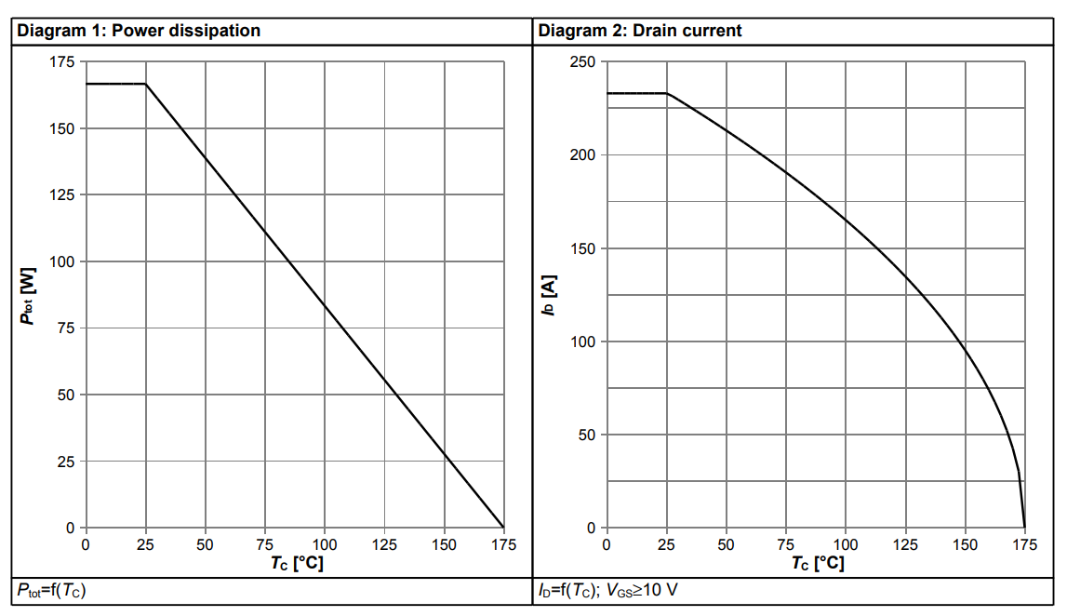

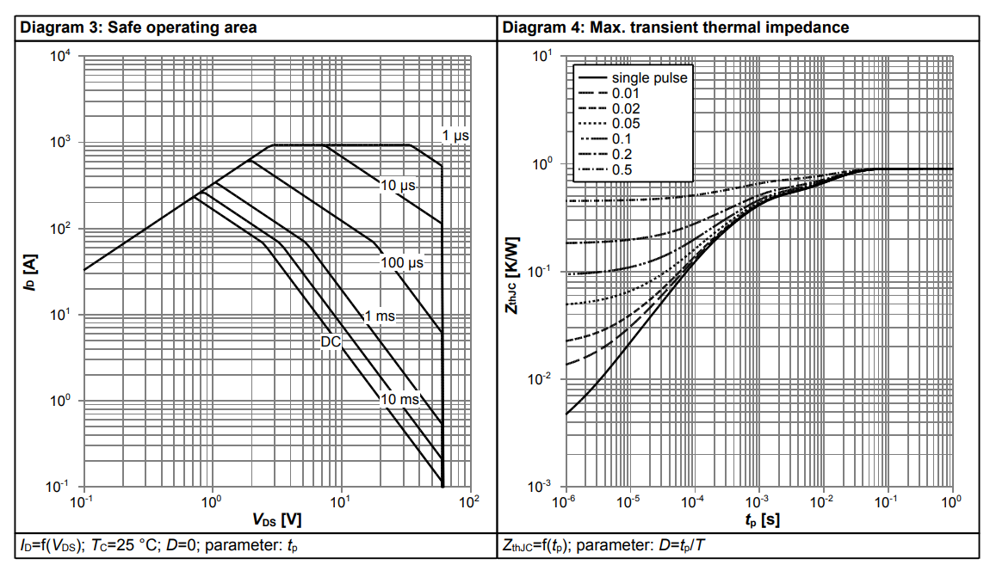

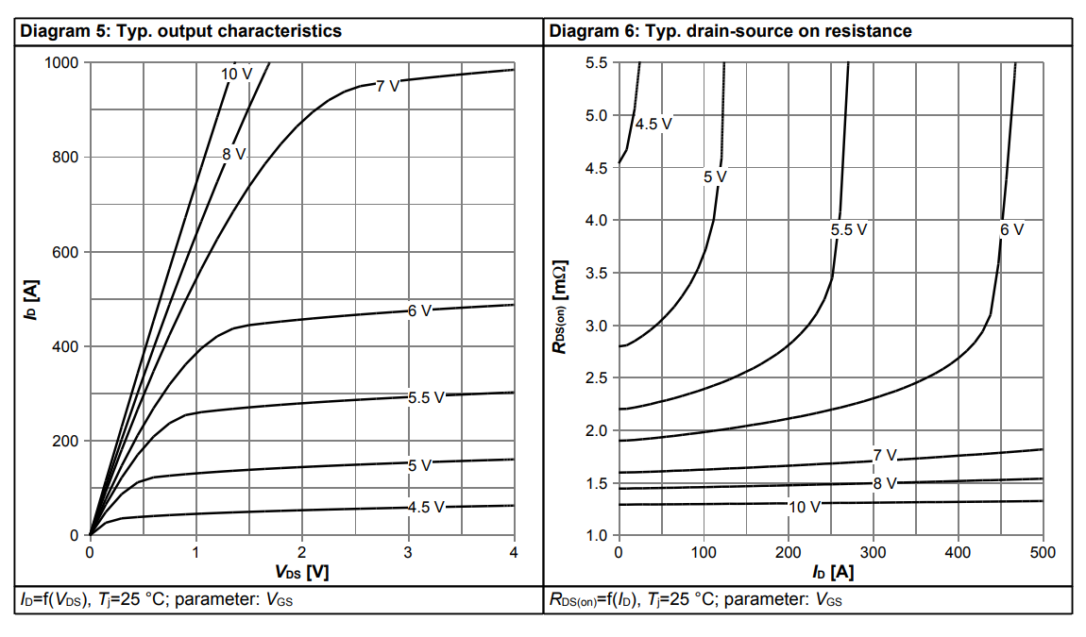

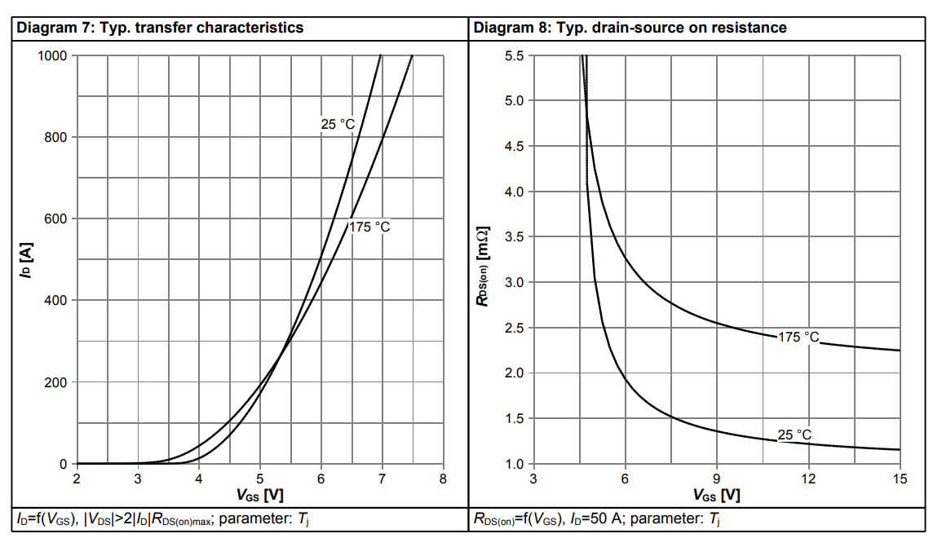

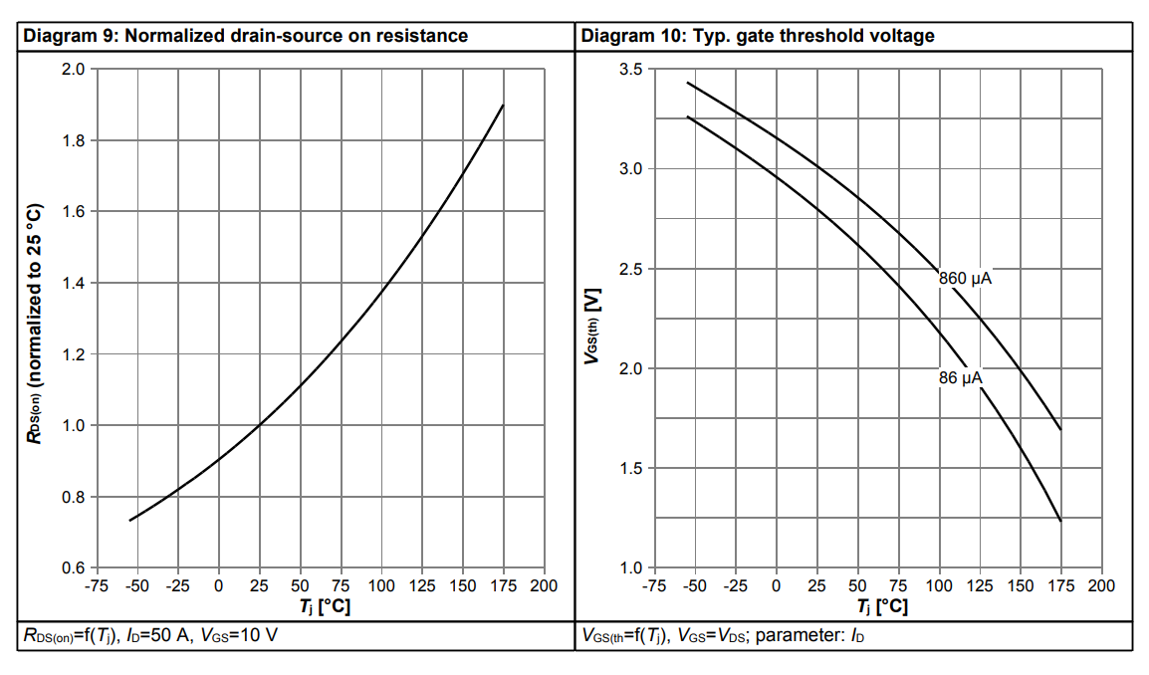

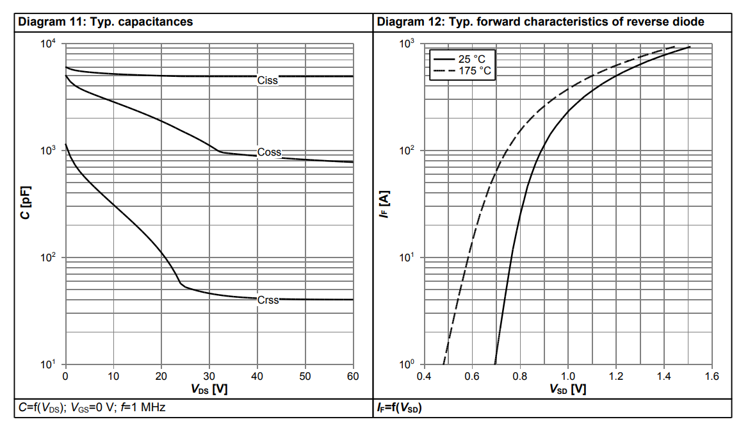

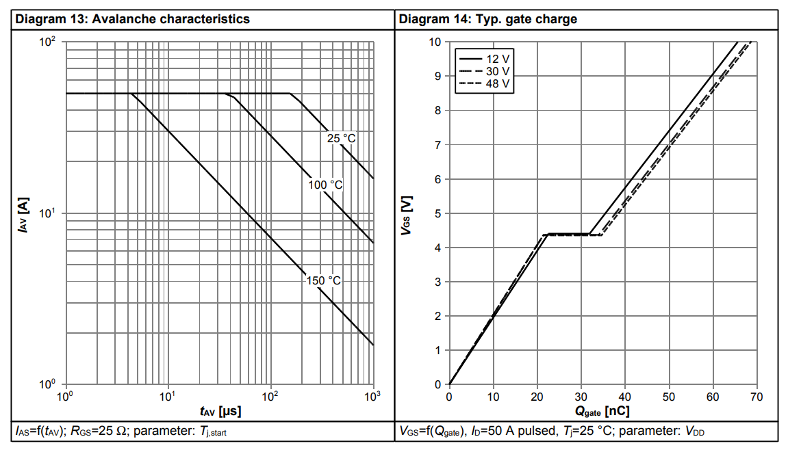

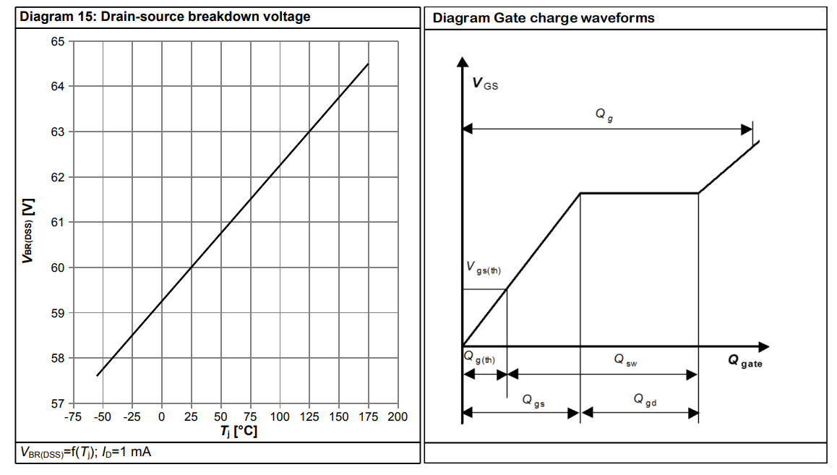

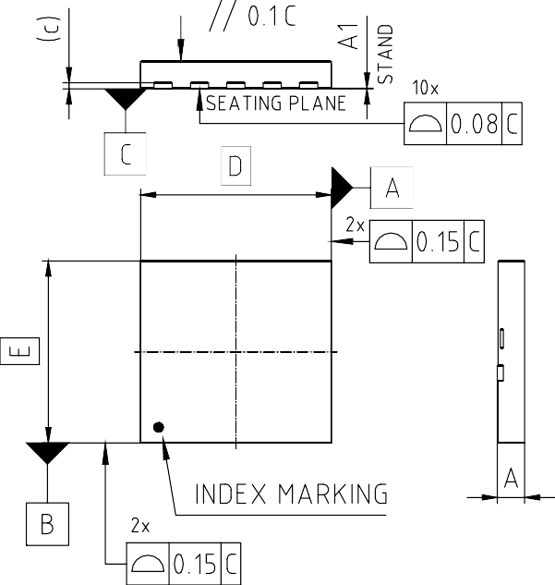
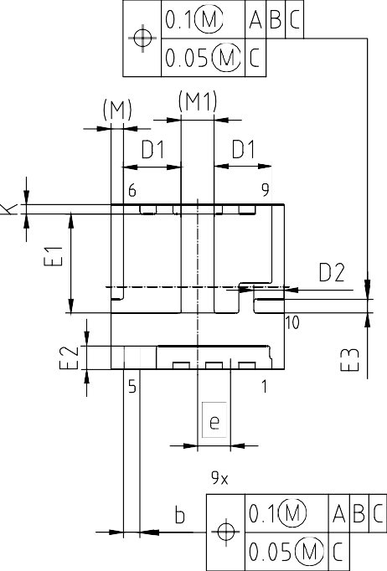
- 封装外形

^{PACKAGE - GROUP} PG-VITFN-10-U01
NUMBER:
DIMENSIONS | MILLIMETERS
DIMENSIONS | MIN. MAX.
A | --- | 1.00
A1 | --- | 0.05
b | 0.55 | 0.65
c | --- | (0.203)
D | 6.30
D1 | 2.00 | 2.20
D2 | 1.05 | 1.15
E | 6.00
E1 | 3.51 | 3.71
E2 | 0.80 | 0.90
E3 | 0.45 | 0.55
e | 1.20
M | (0.45)
M1 | (1.20)
K | (0.35)

图 1 PG-VITFN-10 外形图，尺寸单位为毫米

修订记录

ISG0614N06NM5H
Revision: 2023-12-05, Rev. 2.0

历史修订版本
Revision | Date | Subjects (major changes since last revision)
2.0 | 2023-12-05 | Release of final version

Trademarks
All referenced product or service names and trademarks are the property of their respective owners.

We Listen to Your Comments
Any information within this document that you feel is wrong, unclear or missing at all? Your feedback will help us to continuously improve the quality of this document. Please send your proposal (including a reference to this document) to:
erratum@infineon.com

Published by
Infineon Technologies AG 81726 München, Germany
© 2023 Infineon Technologies AG All Rights Reserved.
Legal Disclaimer
The information given in this document shall in no event be regarded as a guarantee of conditions or characteristics (“Beschaffenheitsgarantie”) .
With respect to any examples, hints or any typical values stated herein and/or any information regarding the application of the product, Infineon Technologies hereby disclaims any and all warranties and liabilities of any kind, including without limitation warranties of non-infringement of intellectual property rights of any third party.
In addition, any information given in this document is subject to customer’s compliance with its obligations stated in this document and any applicable legal requirements, norms and standards concerning customer’s products and any use of the product of Infineon Technologies in customer’s applications.
The data contained in this document is exclusively intended for technically trained staff. It is the responsibility of customer’s technical departments to evaluate the suitability of the product for the intended application and the completeness of the product information given in this document with respect to such application.
Information
For further information on technology, delivery terms and conditions and prices please contact your nearest Infineon Technologies Office (www.infineon.com).
Warnings
Due to technical requirements, components may contain dangerous substances. For information on the types in question, please contact the nearest Infineon Technologies Office.
The Infineon Technologies component described in this Data Sheet may be used in life-support devices or systems and/or automotive, aviation and aerospace applications or systems only with the express written approval of Infineon Technologies, if a failure of such components can reasonably be expected to cause the failure of that life-support, automotive, aviation and aerospace device or system or to affect the safety or effectiveness of that device or system. Life support devices or systems are intended to be implanted in the human body or to support and/or maintain and sustain and/or protect human life. If they fail, it is reasonable to assume that the health of the user or other persons may be endangered.

